Effect of Hydrogen Enriched Hydrocarbon Combustion on Emissions and Performance

The principle of this mode of combustion is to add a percentage of hydrogen gas to the combustion reactions of either compression or spark ignition engines. The addition of hydrogen has been shown to decrease the formation of NOx, CO and unburned hydrocarbons. Studies have shown that added hydrogen in percentages as low as 5-10% percent of the hydrocarbon fuel can reduce that hydrocarbon fuel consumption. The theory behind this concept is that the addition of hydrogen can extend the lean operation limit, improve the lean burn ability, and decrease burn duration.
To apply this method to an engine a source of hydrogen is needed. At this time the simplest option would be to carry a tank of hydrogen. Research is being conducted to allow the hydrogen to be reformed from the vehicles hydrocarbon fuel supply or produce hydrogen from electrolysis of water. In the future, better methods could be developed for storing hydrogen in the vehicle or production of hydrogen on-board the vehicle.
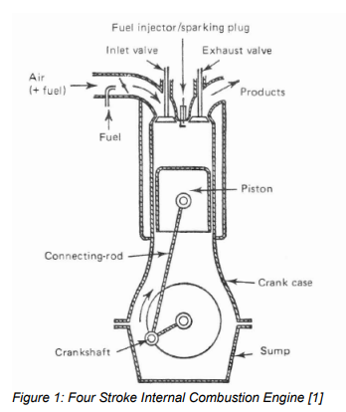
HYDROGEN
Hydrogen holds significant promise as a supplemental fuel to improve the performance and emissions of spark ignited and compression ignited engines. Appendix A shows the properties of hydrogen in comparison to methane and gasoline. Hydrogen has the ability to burn at extremely lean equivalence rations.
Hydrogen will burn at mixtures seven times leaner than gasoline and five times leaner than methane [3]. This lower limit is governed by the Le Chatelier Principle [4].
The flame velocity of hydrogen is much faster than other fuels allowing oxidation with less heat transfer to the surroundings. This improves thermal efficiencies. Efficiencies are also improved because hydrogen has a very small gap quenching distance allowing fuel to burn more completely. The only drawback to hydrogen is that even though its lower heat value is greater than other hydrocarbon fuels it is less dense therefore a volume of hydrogen contains less energy
Click on this link to read through the Idaho University findings of Jacob Wall ---Department of Biological and Agricultural Engineering University of Idaho
The Hydrogen generator that we produce at HFS produces far in excess the volumes that were able to produce such excellent results by Idaho University findings of Jacob Wall https://hydrogenfuelsystems.com.au call Gavan on 0403177183 or email glknox11@live.com

