Installation Instructions for HFS system trucking

Material required for a typical car or Truck:
1). 50 amp double insulated wring;
2). 10mm Ø stainless steel air brake tubing; or 10mm Ø HDPE air brake tubing
3). One 35amp breaker/circuit breaker ;
4) One 35 amp relay switch
4). 10 inch Gas bubbler
5) three 10 mm x ¼ inch BSP straight brass push bock fittings;
6). 500 grams Potassium hydroxide pellets
7) Distilled water

Installation

- You can begin by determining where you want to locate Hydrogen generator system” in/on your path to route the Hydrogen hose and electrical wires from the system device to the engine compartment. You should remember that you will most likely want to run the hose and wires together along a frame member or other similar under-vehicle location where you can attach mechanic's wire or Metal cable ties to hold them in place. You MUST keep both the Hydrogen transfer hose and electrical wire at least 25 cm from the exhaust pipes and exhaust manifold to prevent them from burning, shorting, or melting
- Decide where you want to locate the Hydrogen generator. Then determine a path to route the Hydrogen hose and electrical wires from the “generator” to the power supply in the engine compartment..You should remember that you will most likely want to run the hose and wires together along a frame member or other similar under -vehicle location where you can attach mechanic's wire or metal ties to hold them in place. You MUST keep both the Hydrogen transfer hose and electrical wire at least 25 cm from the exhaust pipes and exhaust manifold to prevent them from burning, shorting, or melting.
- . For inside-vehicle, in-trunk, in-truck-bed, or in-commercial-cargo-bay installations: Once you have determined where you want to locate your “Generator” system, find a place hole for the Hydrogen transfer line and one 3/8" hole for electrical leads ( 30 amp double insulated cable) to the engine compartment. Drill through the vehicle deck to the underside of the vehicle
- Make sure you stay clear of the fuel tank, brake lines, and any other obstructions which would make it difficult for you to push or pull the Hydrogen transfer hose and electrical cable through the holes you have drilled. Then either push or pull the Hydrogen transmission hose through the 3/4" hole you drilled, providing enough slack in the hose near the “Generator” system to push lock fitting on the outside of the system
- . You might want to wrap the transmission Hose with duct tape or apply appropriate size split wire loom where it passes through the vehicle deck in order to reduce the possibility of eventual wear on the Hydrogen transmission hose. Alternatively push the tubing through 12 mm internal diameter reinforced water tubing and fix this water tubing to the underside of the vehicle with metal cable ties / connectors.
- An experienced Automotive electrician should be used to connect the cable to the Battery /alternator so that it is activated from the alternator via a relay switch . Thus when the engine stops and the alternator stops working , then the Relay supplying electrical Power to the Generator system , switches off. This prevents the system working if the engine is not switched on and running.

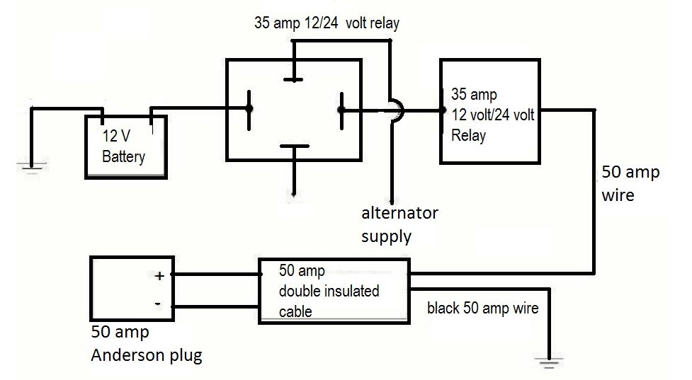
Diagram 1
- Connect the 50amp double insulated cable to the battery positive cable via a 35amp circuit breaker and a 35amp relay unit.
  - Connect a length of red 50amp wire to the positive terminal lug. Connect the other end of the wire to relay terminal 30.
  - Connect relay terminals 85 to the ignition switch via the a) efie thermal switch, b) master switch and 10 amp fuse ( as shown in figure 2). (This will only activate the relay unit when the engine is switched on.). Alternately connect terminals 85 to be activated by the vehicle alternator .

In the case of an efie not being used - Connect relay terminals 85 to the ignition switch via the master switch and 10 amp fuse ( as shown in figure 2). (This will only activate the relay unit when the engine is switched on.). Alternately connect terminals 85 to be activated by the vehicle alternator

  - Connect a wire from relay terminal 87 to the first terminal of the 35 amp circuit breaker. Connect the 2nd terminal of the circuit breaker to the red wire of the double insulated 30amp cable that takes power to the Anderson plug of the system
  - Secure the black cable from the 50amp cable to the body /earth of the vehicle -- ----See diagram 1.
  - e. Connect terminal 86 with a 6 mm wire to the earth of the vehicle

- Then push or pull the 35 amp double insulated cable electrical wires through the 3/8" hole. Double insulated cable is used to protect them from possible wear and shorting. This cable is used to connect the Electrolysis system to the battery/ alternator in your vehicle engine bay.
- Pass the double insulated cable through the vehicle cabin along the line of the wiring loom.
- Attach the free end of the power cable to a 50amp Anderson Plug to connect to the HHO generator
- Mount and secure the 10mm Ø air pipe to the underside of the vehicle using metal ties
- Pass one end of the pipe through the floor of the vehicle rear to connect to the HHO generator

- Locate an area on your air-intake cowling as near the air- intake termination at the throttle throat as you can conveniently access (On diesel engines, you MUST input the Hydrogen transmission hoses UPSTREAM from the turbo, on the LOW PRESSURE side of the turbo). Drill a 7/16" hole
- Remove the air-intake, or move it to a position where the drilling debris won't fall into the throttle throat or intake manifold. Reattach the air-intake cowling and screw a 1/4" BSPT (threaded) x 10 mm Push lock fitting (provided with your hole you drilled in the air -intake. There is no need to over-tighten the fitting(s). If you strip the threads or have trouble satisfactorily affixing the fitting into the air-intake cowling, you can clean/de-grease the area around the hole(s) and use any good plastic glue epoxy, Sumo Glue, etc., to secure the fitting
- Attach the Hydrogen transmission hose (10 mm trucking air brake tubing) to the Push lock fitting you attached to your air-intake . You might double-check to be sure you have chosen a route for the hose and wire that will avoid the hot exhaust manifold and exhaust pipes as well as avoiding any moving mechanisms that would entangle, crimp, or rub the hose. Again, it would be a good idea to follow the same path as the electrical Cable so the hose and the cable can be bundled with electrical or duct tape as you attach and support them with plastic ties and/or mechanics wire as they traverse along the vehicle framework generator” and the engine compartment

Diagram 2
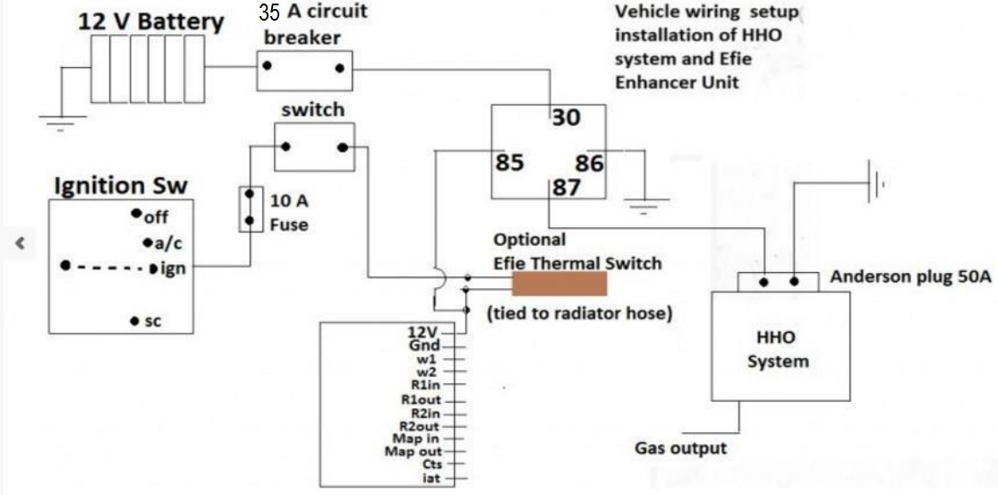

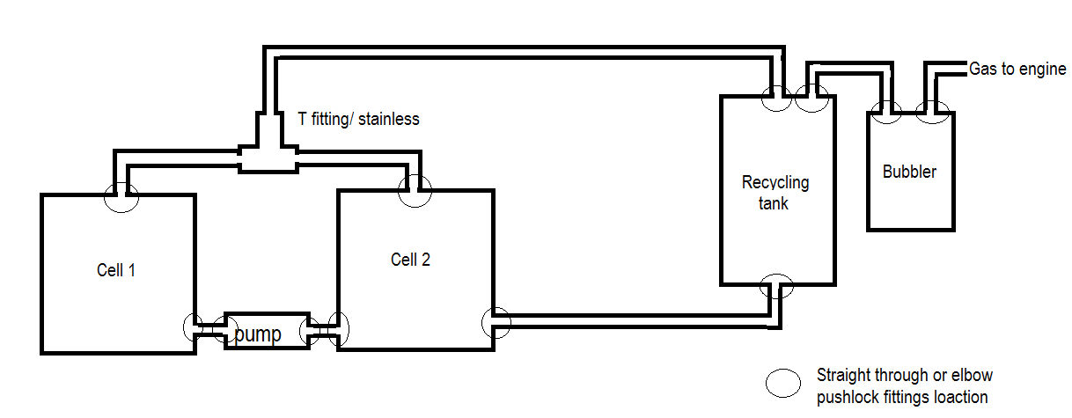
Twin Gen 20 systems mounted onto truck

